**MIDDLE EAST TECHNICAL UNIVERSITY**

**DEPARTMENT OF CIVIL ENGINEERING**

**CE 447: MATERIALS OF CONSTRUCTION**

**TERM REPORT**



**Mix Design and Properties of 3D Printable Cement-Based Composites Incorporating Fly Ash**

**Cemilcan AŞIKOĞLU**

**2226504**

**SUBMISSION DATE: 2/1/2021**

Table of Contents

Abstract 1

1. Introduction 2

2 Literature Background 3

2.1 Properties of 3D Printable Concrete 3

2.1.1 Extrudability 3

2.1.2 Shape Retention 3

2.1.3 Thixotropy 3

2.1.4 Buildability 3

3. Materials and Methods 3

3.1Fly Ash (FA) 4

3.2 Ordinary Portland Cement 5

3.3 Nano Clays (NC) 6

4. Discussion and Result 9

4.1 Effect of HVFA on 3D Printability 9

4.1.1 Extrudability and Shape Retention 9

4.1.2 Buildability 10

4.1.3 Effect on Compressive Strength 11

4.2 Effects of Nano Clays 11

4.2.1 Flow Properties 11

4.2.2 Buildability 12

5. Conclusion 14

6. References 15

# Abstract

One of the 3D printing technology applications is cement-based composites. In terms of viscosity, microstructure properties, heat of hydration, mechanical performance (tensile, compressive, shear), 3D printability (viscosity and thixotropy); mix design of cement-based composites incorporating fly ash in the construction industry is investigated in this study. Fly ash is used for 3D cement-based composites in order to decrease the heat of hydration (high heat of hydration cause deformations and water loss). To develop a printable mix, the main aim is design a thixotropic material which means having abilities such as extrudability , keeping its original shape after deposition without show any deformation. For cement-based mix, this generally depends on continuation of hydration and flocculation of particles. To improve mechanical performance and the thixotropy of cement pastes, nano-attapulgite clay (NC) are used in cement mix. The mix design with proper amount NC demonstrated promising results in terms of extrudability, buildability layer -by- layer without any deformation. Using NC and fly ash in 3D concrete printing show better results in geometrical and mechanical properties.

**Keywords:** 3D printing concrete, HVFA, nano clay, concrete mix design, nano clays

# Introduction

In today’s technology, the 3D printing has been an important branch which are widely used in different areas. In terms of construction, this technology is also important and some of techniques and mixes are developed to use this technology. The most common mixes are 3D printable concrete mixes. To achieve a proper physical, chemical, mechanical behavior in 3D printing concretes, different approaches and substances have been used and been developing.

The reasons behind the why 3D printing has been rapidly used in construction are in 3D printing, the ability to manufacture complex structure is simple than casting or other construction techniques, the more productivity and quality, the efficiency of using materials and higher cost efficiency and universality. Thanks to 3D printing technology, a CAD model can be directly produced therefore, the limitation about design and geometry is less than other production techniques. Like extrudability, shape retention is also a crucial factor for 3D concrete printing. After extruding, the material must retain its shape as per the extruder dimension and it can be quantified by a dimensionless number called shape retention factor (SRF) which is

SRF = Cross sectional area of 3Dsample before demoulding Cross sectional area of 3Dsample after demoulding it is collected from the combustion residue it is collected from the combustion residue it is collected from the combustion residue [1,2]

When producing a proper printable cement-based mix, there are some criteria that has to be considered. The main challenge in the development of a printable mix is the design of a thixotropic material that can be easily extrudable during the printing process, while maintaining its original shape after deposition. Thixotropic behavior is a common rheological phenomenon that illustrates the decrease of viscosity of a colloidal suspension at a constant or increasing shear rate and the recovery of viscosity when the material is at rest.[3,4]To achieve desired properties, some of additives such as fly ash, silica fume, nano clays geopolymer additives etc. are used. They have different effects on mix, and they can affect to whole mix. In this report, 3D printable concrete mixes incorporating fly ash are examined and the reason why fly ash used, what are the positive and negative effects of using this, mechanical and chemical properties of fly ash concrete mix are explained. Also, the impact of nano clays on this mix are conducted.

# **Literature Background**

## **2.1 Properties of 3D Printable Concrete**

To achieve a proper 3D printable concrete mix, some properties have to be achieved.There are some of important properties that any proper mix have to have.

### **2.1.1 Extrudability**

In concrete printing, extrudability can be defined as the material ability to be pumped out smoothly through an extruder without any disruption/clogging in the pipe flow.[5]

### **2.1.2 Shape Retention**

Like extrudability, shape retention is also a crucial factor for 3D concrete printing. After extruding, the material must retain its shape as per the extruder dimension and it can be quantified by a dimensionless number called shape retention factor (SRF) which is

### **2.1.3 Thixotropy**

Thixotropy is defined as the progressive decrease in viscosity with time for a constant applied shear stress, followed by a gradual recovery when the stress is removed.[6]

### **2.1.4 Buildability**

Buildability is defined as the ability of an extruded cementitious material to retain its geometry (shape and size) under sustained and increasing loads in fresh or transient state.[7]

# 3. Materials and Methods

When designing a printable concrete mix, the amount, the type, the properties of materials that used affect the properties of whole mix. In order to achieve a proper mix, the materials have to be known clearly. So, in this section, materials are used for mix design are mentioned.

## **3.1Fly Ash (FA)**

Almost 50 years, FA have been used with Portland Cement. It is produced from thermal power plants as by- product, combustion residue.

In general, FA consists of glassy spheres of sizes varying from 1 to 150 μm and based on mineralogical composition, it can be divided into two categories such as Class F and C. Class F FA contains SiO2 + Al2O3 + Fe2O3 > 70%, and very less CaO (<5%), whereas Class C contains SiO2 + Al2O3 + Fe2O3 > 50%, and more CaO (around 20%).[8]

If the rate of FA in concrete mix is higher than 50%, this mixes called as high volume fly ash concrete mix (HVFA). The reason behind the usage of FA instead of PC is reduce the carbondioxide emission and so it can be said that the usage of FA has positive impact on the sustainability and CO2 emission.

Like PC hydration , reacting with Ca(OH)2 FA also produce calcium-silicate hydrate (C-S-H) gel, that constitute 40% to 70% of the hardened state of PC and gives crucial properties like strength. Also, as another advantages of FA usage are educed water demand, heat of hydration, drying shrinkage and reduced permeability, which will reduce the sulphate and chloride ingress. It increases workability, compressive strengths (after 56 days) and gives a better surface finish to concrete due to the spherical shape, which in other hand improves the durability by reducing water requirement.[9]

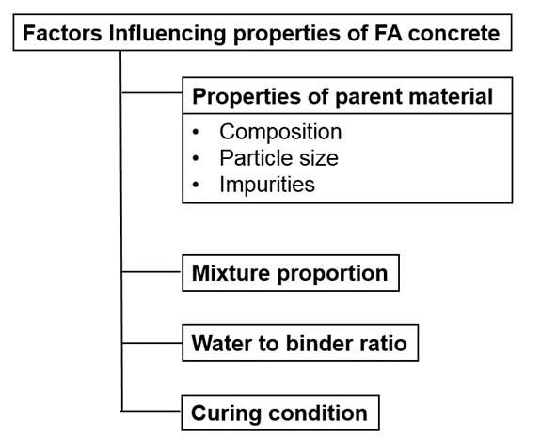

Figure 1: The factors that influence the properties of FA[10]

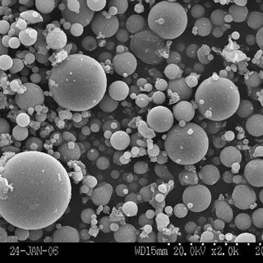

Figure 2: The SEM of FA

## **3.2 Ordinary Portland Cement**

Cement has been used about 150 years in all type of construction such as bridges, buildings etc. Ordinary Portland cement ( or Portland cement) is the hydraulic binding material consisting of Portland cement clinker, 0-5% limestone or granulated blast furnace slag, and a limited amount of gypsum.[11] The names and contents of the main mineral composition in Portland cement clinker are as follows:

Tricalcium Silicate (3CaO-SiO2, abbreviated as CS3), accounting for

Tricalcium Silicate (3CaO-SiO2, abbreviated as C$3), accounting for37%-60%

Dicalcium Silicate (2CaO*Si02 abbreviated as C*S), accounting for 15%-37%

Tricalcium Aluminate (3CaO*A1203, abbreviated as C3A), accounting for 7%-15%;

Tetracalcium Aluminoferrite (4Ca0*AI2O3*Fe203, abbreviated as GAF), accounting for 10%-18%.

In addition to these four major minerals, there are a small amount of free calcium oxide, magnesium oxide, and alkali in cement which are clearly prescribed in the national standards that the total amount should not be more than 10%.[11]

In 3D printing technology, PC is commonly used with many additives to improve printing performance. Some of these are FA, NC.

metin, ağaç içeren bir resim

Açıklama otomatik olarak oluşturuldu

**Figure 3: The SEM of OPC (a) fresh state, (b) hardened state**

## **3.3 Nano Clays (NC)**

As an additive, nanoclays can be used in 3D printing cement mixes. The form of nano clays are highly-purified magnesium aluminosilicate and the They had a diameter of ∼3 nm, while their length varied from 1.5 to 2 μm. [12]

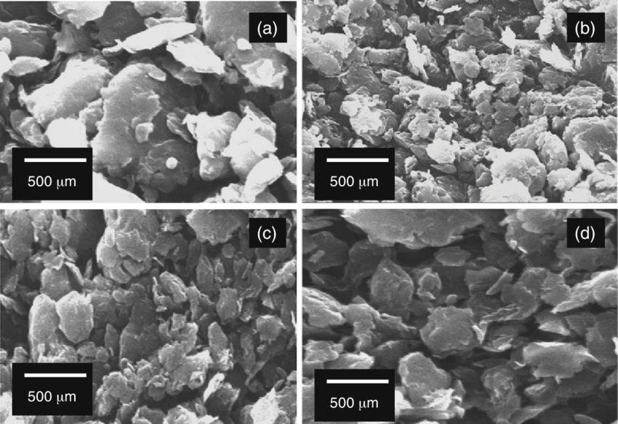

**Figure 4: The SEM of NC**

By using these 3 materials, sand and water some experiments are conducted on different mixes in the study of ‘*Experimental study on mix proportion and fresh properties of fly ash based geopolymer for 3D concrete printing’* by Biranchi Panda, Ming Jen Tan. The mixes can be seen on Table 1.

Table 1: Different Mixes that used for experiments(water binder ratio 0.35)[10]

tablo içeren bir resim

Açıklama otomatik olarak oluşturuldu

PV (Paste Volume): PC+ FA + water

To observe the behaviors of NC on mixture, a mixture which have 0.05% NC are prepared and result are compared with control mix. The compound rate of control mix is 70% FA- 30% PC without any NC.

# 4. Discussion and Result

## **4.1 Effect of HVFA on 3D Printability**

4.1.1 Extrudability and Shape Retention

In the experiments, due to high sand amount, M42 and M44 didn’t not pass the 3D printer’s nozzle- pipe- pump system. But when other mixes considered, these mixes can be considered as suitable for printing. From these experiments, PV has a lubricant effect on sand particle and due to these effect, after 46% of PV, proper printing results are obtained. Also, from these experiments, it can be said when the PV increase, the force that push the mix for printing decrease. The effect can be seen this figure:

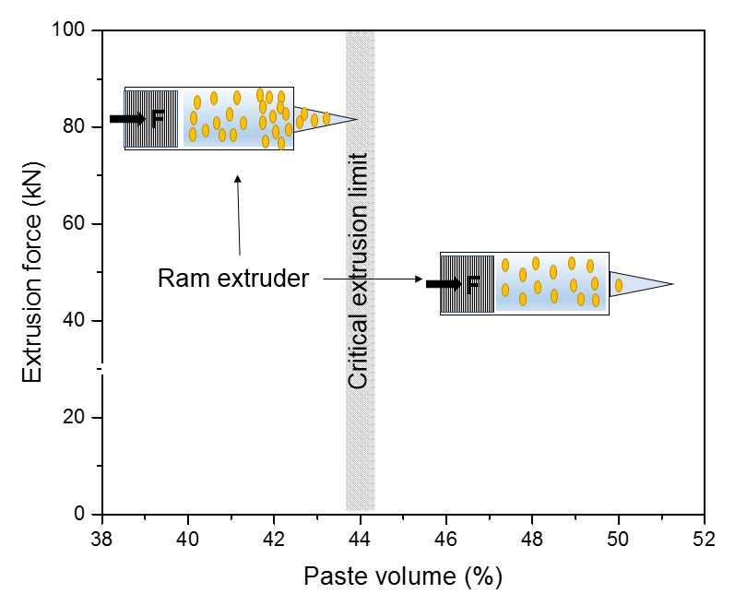

Figure 5: Extrusion force vs Paste Volume[10]

In terms of shape retention, it can be said that the increase of FA amount, yield stress and viscosity decreases because of spherical shape of FA. Therefore, this effect increases the workability of mix. In this figure, the results can be seen:

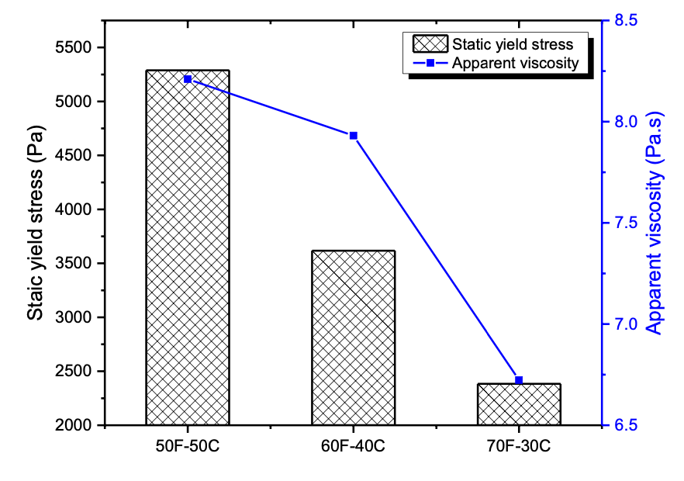

Figure 6: Yield Stress and Viscosity of M46

### **4.1.2 Buildability**

To understand the buildability behaviors of HVFA, 2 different mixes which are 50% FA-50%PC and 70% FA-30% PC used.

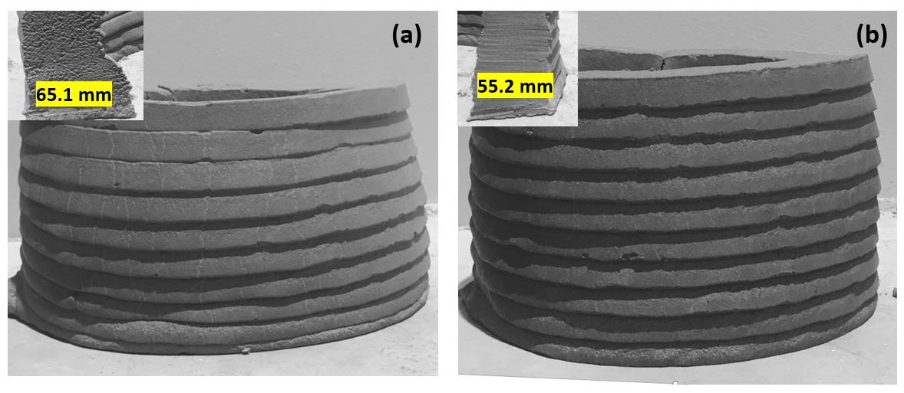

**Figure 7: Buildability of HVFA mixture with (a) 70%FA-30%PC (b) 50% FA-50%PC**

From these figures we can say that high volume of fly ash cause early deformation while both mixture are completely deformed. However, the increase in PC ratio cause a more stable layering which can be explaning by 65.1 mm to 55.2 mm.[10]

### **4.1.3 Effect on Compressive Strength**

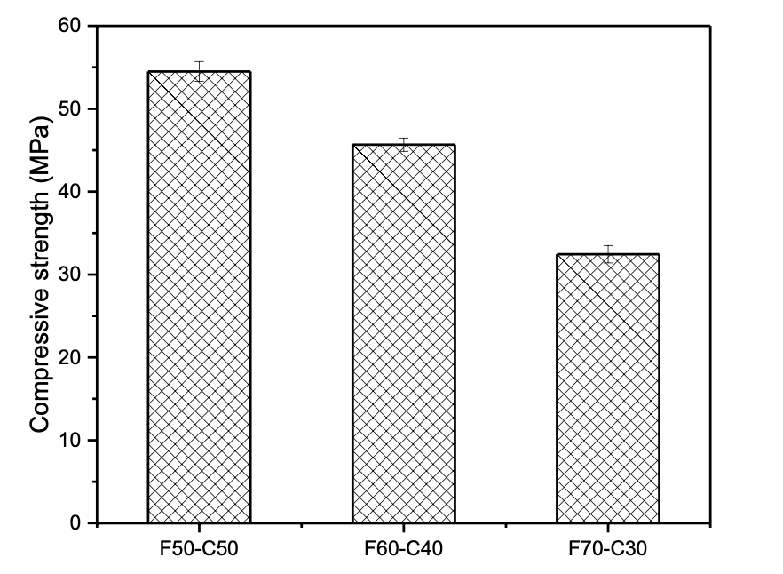

**Figure 8: Compressive Strength of Mixtures**

In terms of compressive strength, addition of the FA decreases the 28 days strength due to dilution effect.[10]

## **4.2 Effects of Nano Clays**

### **4.2.1 Flow Properties**

From the figure above, it can be said with NC ratio increase, the yield strength of mixture increases without significant viscosity rate. This behavior called thixotropy that very useful at 3D construction printing.

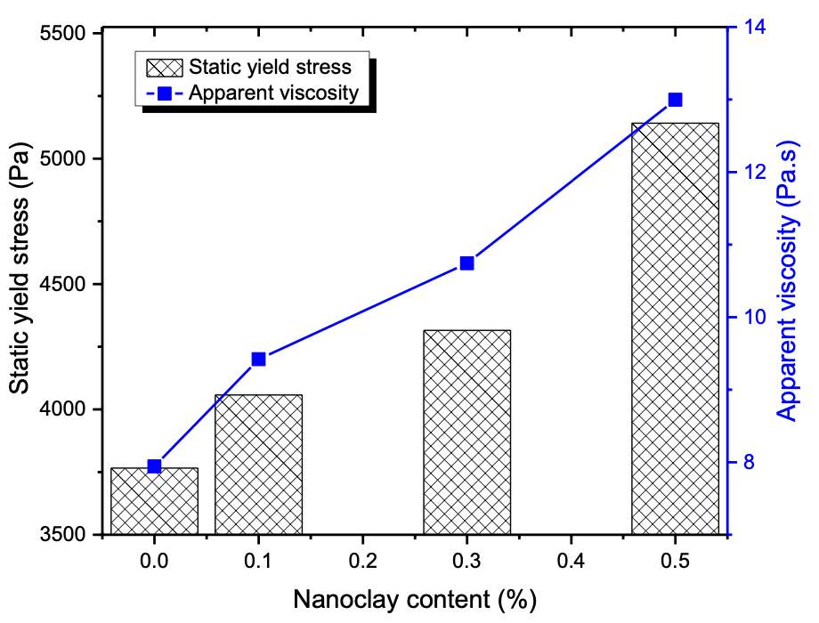

**Figure 9 : NC RAtio vs Static Yield Strength and Viscosity**[10]

### **4.2.2 Buildability**

Thanks to the thixotropy behavior of NC mixture, more buildable mixes can be produced. By using NC, without showing any deformation, a structure has more layers can be produced. This result can be seen on Figure 10. While control mix which have no NC was deforming at 10th layer, the mixture have NC can be produce 20 layer without any deformation.

iç mekan içeren bir resim

Açıklama otomatik olarak oluşturuldu

**Figure 10: Buildability of (a) Control mixture (b) NC mixture**[10]

# 5. Conclusion

In these reports, the behaviors of different mixes which are prepared to 3D concrete printing are examined. Increasing of usage of 3D printing technology, different mixtures are examined to build better structures with high efficiency, with less material and cost, less CO2 emission and with desired properties.

In the first section, some literature information is given and the next section of report, the method and materials that used in experiments are given. In the discussion of results section, the behaviors of FA and NC mixtures are examined in terms of extrudability, shape retention, buildability, compressive strength, thixotropic behaviors which static yield strength and viscosity are examined. From these results it can be said using FA has positive effect on extrudability, shape retention and workability of 3D printing mixture, although, the buildability decreases with FA rate due to dilatation effect. Also, using high amount FA in mixtures decrease the compressive strength. However, by using the FA, CO2 emission can be decreased significantly because FA is a by- product of thermal power plant. Also, some desired properties such as decreasing heat of hydration can be achieved.

In addition to these, the using of NC in 3D mixture, buildability and thixotropy behaviors can be increased. NC has a great impact on buildability and thixotropy of mixture and so that more layered structured can be build more easily with 3D printers.

# 6. References

[1] T.D. Ngo, A. Kashani, G. Imbalzano, K.T.Q. Nguyen, D. Hui, Additive manufacturing (3D printing): A review of materials, methods, applications and challenges, Compos. Part B Eng. 143 (2018) 172–196. https://doi.org/https://doi.org/10.1016/j.compositesb.2018.02.012.

[2] I. Farina, F. Fabbrocino, G. Carpentieri, M. Modano, A. Amendola, R. Goodall, L. Feo, F. Fraternali, On the reinforcement of cement mortars through 3D printed polymeric and metallic fibers, Compos. Part B Eng. 90 (2016) 76–85. https://doi.org/https://doi.org/10.1016/j.compositesb.2015.12.006.

[3] N. Roussel, G. Ovarlez, S. Garrault, C. Brumaud, The origins of thixotropy of fresh cement pastes, Cem. Concr. Res. 42 (2012) 148–157. https://doi.org/https://doi.org/10.1016/j.cemconres.2011.09.004.

[4] N. Roussel, Rheological requirements for printable concretes, Cem. Concr. Res. 112 (2018) 76–85. https://doi.org/https://doi.org/10.1016/j.cemconres.2018.04.005.

[5] J.F. Chhabra, R. P., & Richardson, Non-Newtonian flow and applied rheology: engineering applications., Butterworth-Heinemann, 2011.

[6] B. Panda, M.J. Tan, Experimental study on mix proportion and fresh properties of fly ash based geopolymer for 3D concrete printing, Ceram. Int. 44 (2018) 10258–10265. https://doi.org/10.1016/j.ceramint.2018.03.031.

[7] T.T. Le, S.A. Austin, S. Lim, R.A. Buswell, A.G.F. Gibb, T. Thorpe, Mix design and fresh properties for high-performance printing concrete, Mater. Struct. 45 (2012) 1221–1232. https://doi.org/10.1617/s11527-012-9828-z.

[8] D. Ravina, P.K. Mehta, Properties of fresh concrete containing large amounts of fly ash, Cem. Concr. Res. 16 (1986) 227–238. https://doi.org/https://doi.org/10.1016/0008-8846(86)90139-0.

[9] Ş. Targan, A. Olgun, Y. Erdogan, V. Sevinc, Influence of natural pozzolan, colemanite ore waste, bottom ash, and fly ash on the properties of Portland cement, Cem. Concr. Res. 33 (2003) 1175–1182. https://doi.org/https://doi.org/10.1016/S0008-8846(03)00025-5.

[10] B. Panda, 3D printing of high-volume fly ash mixtures for digital concrete construction, 2019. https://doi.org/doi:10.32657/10356/93583.

[11] H.B.T.-B.M. in C.E. Zhang, ed., 4 - Cement, in: Woodhead Publ. Ser. Civ. Struct. Eng., Woodhead Publishing, 2011: pp. 46–423. https://doi.org/https://doi.org/10.1533/9781845699567.46.

[12] B. Panda, S. Ruan, C. Unluer, M.J. Tan, Improving the 3D printability of high volume fly ash mixtures via the use of nano attapulgite clay, Compos. Part B Eng. 165 (2019) 75–83. https://doi.org/10.1016/j.compositesb.2018.11.109.